SOFTWARE REQUIREMENTS
SPECIFICATION

FOR

BOOK MANAGEMENT
SYSTEM

SUBMITTED BY
NAME | ROLL NO
ABHINAY SHUKLA | 44
SURAJ YADAV | 60

PROBLEM DEFINITION

1. EXISTING SYSTEM:
The existing system is a manual one. Different records are maintained for different transactions of the Library. When a new transaction takes place, the Librarian staff enters the details of the transactions in a new file depending upon the type of the transaction. The staffs have to maintain different type of operation like keeping details of the members i.e. General member as well as Student, detail records of books, keeping track of members newly registered moreover financial transactions like income and expenditure for the period. The reports are generated time to time for various operations; these should also be produced to the higher authority in timely manner. The information regarding the system needs interaction and presentation at regular intervals of time.
2. PROBLEMS WITH THE EXISTING SYSTEM:
Since the system is a manual one, the new transactions become time consuming. The procedure of modification and deletion with the new transaction requires much interaction with the system. Those records may already be in use at some level of processing. This causes delay in the process.
The lack of availability of information in the same manner between different modules of the system slows the whole process. The lack of coordination of the staffs and procedures in a horizontal manner can a/so speed down the whole process, which requires more or less uninterrupted flow of information.
3. NEED FOR COMPUTERIZED SYSTEM
A computerized system is needed mainly because of the lack of speed in the manual system. Computerized system provides speed with accuracy. The new transaction entries can be made instantly. The modification and deletion of records regarding the transaction can be done in no time. The new system will not only make modification and new transaction faster but also speedup the report generation. The generation of reports will become time effective and the scope of generation will also increase. The information flow will become faster. The transparency level will also increase. The coordination between different modules will also increase. The manpower and the paper work needed for maintaining the operation of the Library will be reduced by the introduction of the computerized system.

LIMITATION OF CURRENT SYSTEM

The current system has lots of limitation which our book manegment system can solve it. In current system lots of manual work is required from creating product requisition to generating purchasing order. This slow down the growth of the organization. Sometime when the organization purchase the desired goods and service it become difficult for them to manage proper format of buying that product and proof of buying that goods and services. In large organization where there is no proper check the managers and staff member may engaged in fraud. They order the goods and services for their personal use.
The current system is somewhat very complex to operate. Some user may not be the expert in procurement process and does not have proper knowledge of the requisition and purchasing order system. They need easy-to-use system which do most of the work automatically.

ADVANTAGES
All the educational institutions should know following advantages of the
Book Management System:
Record Maintenance
Saves Time and Cost
Secure and Reliable
Simple and Easy to Use
Record Maintenance
All records related to the book issued and return deadline can managed by the authorized personnel. The system also allows to record the fine received from the student in the same platform, which eases the work of reporting for the book department.
Saves Time and Cost
It eliminates paper-based processes and reduces operation costs and saves time of the book management. So, library will become free of number of registers and files.
Secure and Reliable
The paper based process might incur data loss, however in case of book Management System, it is much secure and reliable. Only the authorized personnel can login to the system and use it.
Simple and Easy to Use
The system is very user-friendly and easy to use. You do not need to be an IT professional to handle it.
The Library is one of the vital department in every educational institution, and each institutions have different needs. We do not restrict the system to particular pre-developed features and the system can be customized as per the requirement.

FEASIBILITY STUDY

When a new system is to be introduced, there is a need to study the new system in every aspect or manner before working on it. Feasibility study helps us to get an idea weather the project is adequate or not.

- Technical Feasibility
Since our project is in C++ language we need to have a strong understanding in the C++ programming. The proposed system required a computer with the CodeBlocks installed or any C++ development environment.
- Economical Feasibility
The proposed system does not require any additional hardware system as the required software for the development of the purchase requisition and purchasing order system can be easily installed on the existing hardware.
The proposed system is economically feasible to implement.
- Operational Feasibility
The proposed system can be easily install on any system and it is easy to use. The user can easily use this system without any problem. Therefore our system is operationally feasible.
FUNCTIONAL REQUIREMENT

1. Login – for ever user or admin they have to login before access

2.Add User – admin can add user in it

3.Update And Delete User – in this we can update data base and delete user of it

4.Search User if we need data of the user we can directly add the data id to get detail

5.Add Book books can be add directly by feeling some information

6.Update and Delete Book in this we section

7.Search Book we can directly the searching of the book

8.Issue Book in this we can issue the book to the user

9.Return Book we can update database of book that book is return

10. Report we can generate overall report in one place at one touch

NON-FUNCTIONAL REQUIREMENT

The non-functional requirement of the proposed system is given below:

Performance Requirements
– Performance of the system should be fast and accurate.
– System shall handle expected and unexpected errors.
– Should be able to handle large amount of data.

• Safety Requirements
– Must be two servers one main server and one backup server.

• Security Requirements
– User authentication and validation of members using their unique member ID.
– Proper accountability which include not allowing a member to see other members account.
– Only administrator will see and manage all members account.
– Proper user authentication should be provided.

HARDWARE REQUIREMENT

Operating System | Windows 7/8/10
RAM | 8 GB Recommended
Disk Space | 500 MB Disk Space
Screen Resolution | 1080 X 1920 pixels

SOFTWARE REQUIREMENT

C++ Code Editor | CodeBlocks
Text File Editor | Notepad/ Notepad++

SYSTEM FLOWCHART
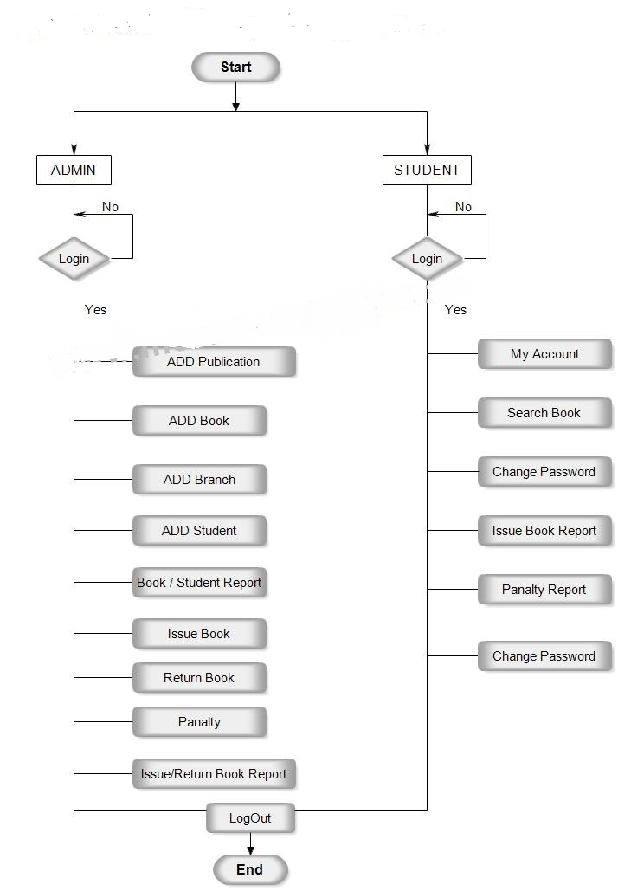
USE CASE DIAGRAM
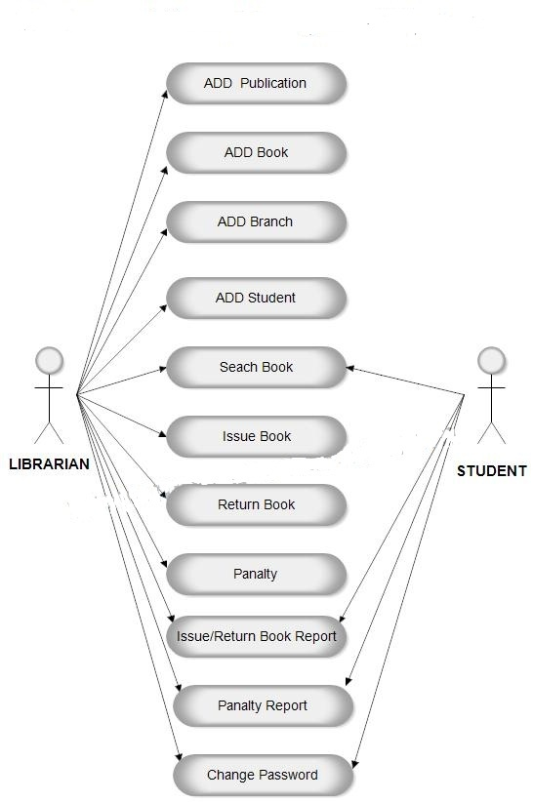

DATA FLOW DIAGRAM

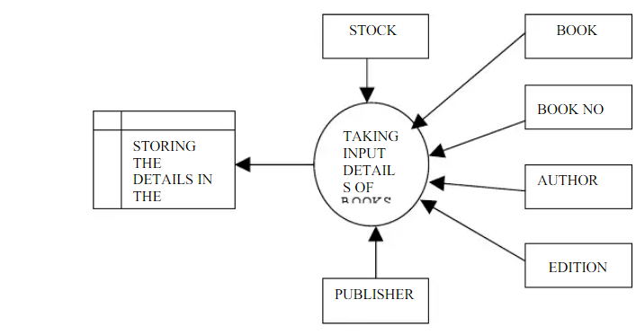

TESTING

Test Case ID | Test Case Objective | Steps | Input Data | Expected Output | Actual Output | Status
1 | Test Create New user and book | 1. Select 1st option.  2. Enter Details. | User and Book | Store user and book Details | Store user and book Details | PASS
2 | Test Display user and book | 1. Select 2nd Option. |  | Display user and bok | Display user and book | PASS
3 | Test Generate  issue book | 1. Select 3rd Option. | - | Generate issue book | Generated issue book | PASS
4 | Test View return book | 1. Select 4th Option. | - | Return a book | Return a book. | PASS

IMPLEMENTATION AND MAINTENANCE

In every book, maintenance of library material involves continuous monitoring of the stack room, displaying of new material on the display racks and arrangement of the books and periodicals on the shelves after use. Besides these, the material has to be dusted and cleaned at periodic intervals. The periodicals, damaged and torn books have to be bound. The old and obsolete documents which are no longer in use have to be withdrawn from the stacks. This also includes physical care of the books, that is, their protection from sunlight, dust, insects, moisture and heat. The maintenance work is related to many sections of the library. For example, the processing section makes available new material all the time and there is a need to shelve these books within the already existing collection. This creates problems of shelving when books on the same subject are received in large numbers. These books have to be accommodated on the shelves without disturbing the order of arrangement of other collection. The circulation section too is involved. The users, continuously pick up books from the stacks, get them issued and eventually return them. Upon their return from users, these books have to be put back in their proper places on the stacks. Therefore, the work related to proper shelving, re-shelving and maintaining the collection is continuous in nature. Besides this, the work related to periodicals is separate from the rest of the library work. Effective service involving periodicals can be provided only by separating them from the rest of the library’s collection.

